**JENKINS SLAVE SETUP**

Before Launching Jenkins, first follow these steps:

Launch Oracle VM Workstation.

Launch Putty and login into vagrant

IP: 192.168.33.10

User Name/Password: vagrant/vagrant

At CLI go to path home by using command ‘**cd home**’

[vagrant@localhost ~]$ ls

[vagrant@localhost ~]$ cd /home/vagrant/subversion-1.9.4-1/

[vagrant@localhost subversion-1.9.4-1]$ sh ctlscript.sh restart

[vagrant@localhost subversion-1.9.4-1 cd ../

[vagrant@localhost ~]$ java –jar Jenkins.war

Once we run this command we can see/able to launch the Jenkins in web browser.

Open Browser: 192.168.33.10:8080

Now Click on “Manage Jenkins”.

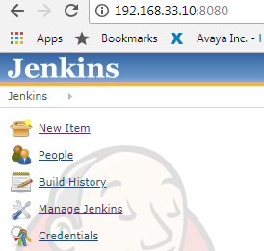

Scroll down and click on “**Manage Nodes**”

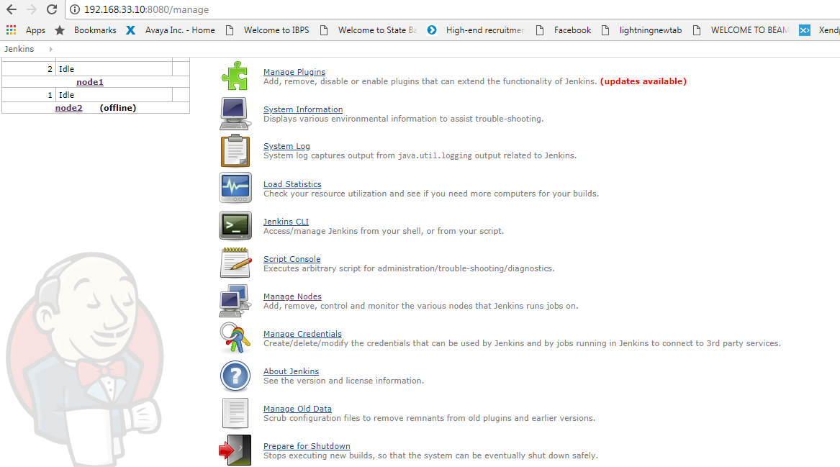

Click on “New Node”.

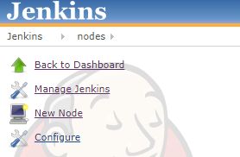

Provide Node Name: prac1 and click on Radio button “Dumb Slave”.

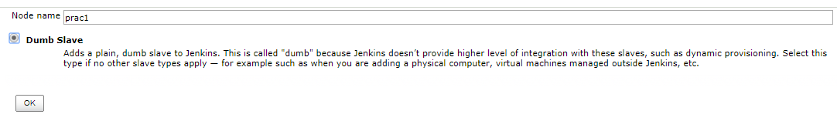

Next Page will display like below:

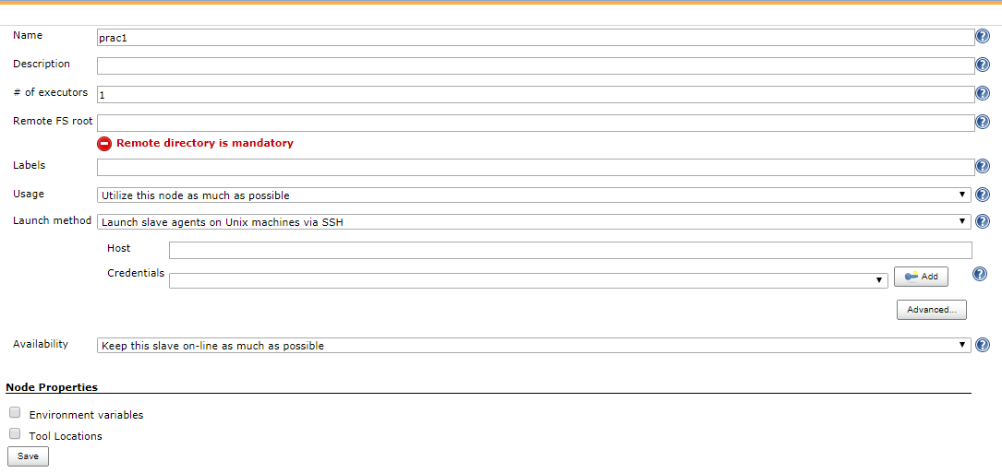

Here provide Description.

Provide Remote FS Root: (This is for to store the Jenkins logs, for this to create one folder in Desktop and copy the URL and paste in Remote FS Root).

Change the Launch Method to: “**Launch slave agents via Java Web Start**” from the drop down.

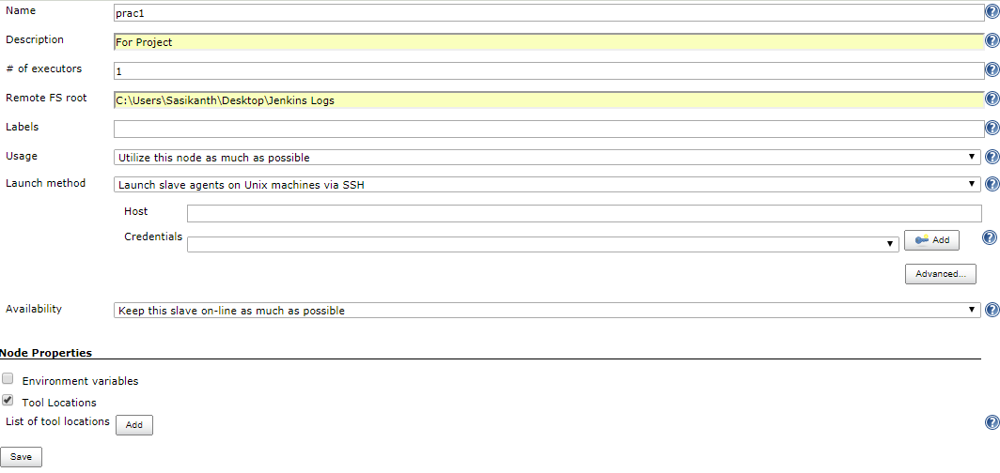

Click on Save.

Once saved we can see below like this:

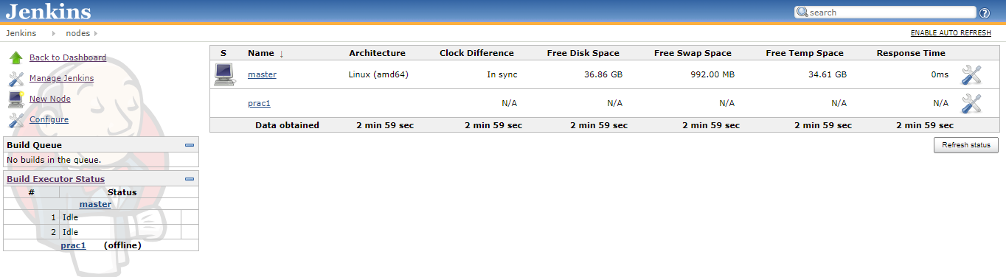

Click on Manage Jenkins

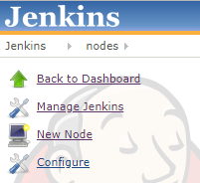

Click on “Configure System”.

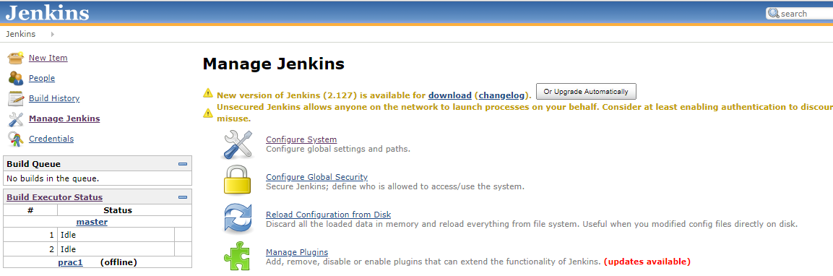

It will redirect to below page: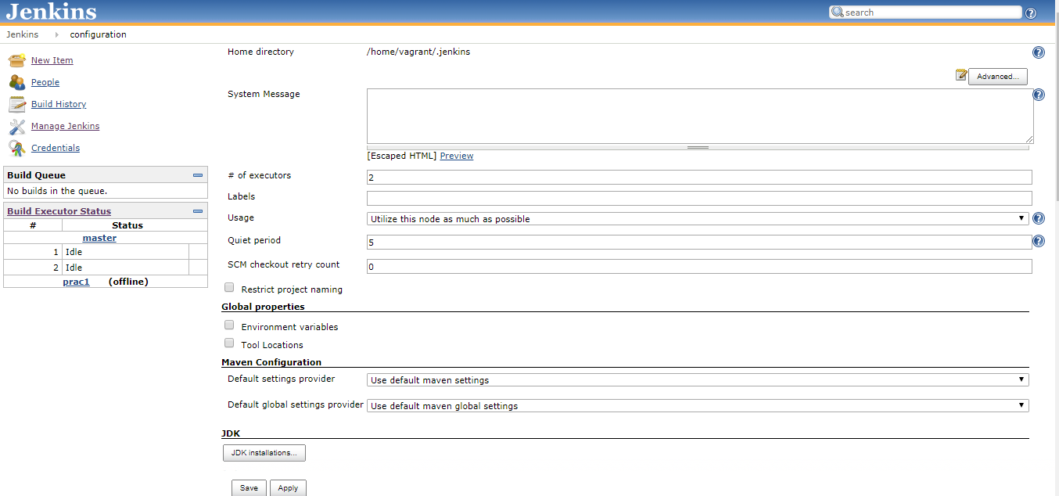

Scroll down and Click “Add JDK”.

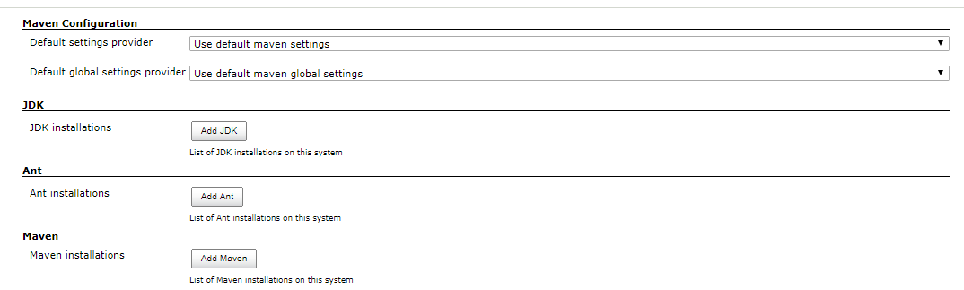

Once we click on Add JDK we can see below display.

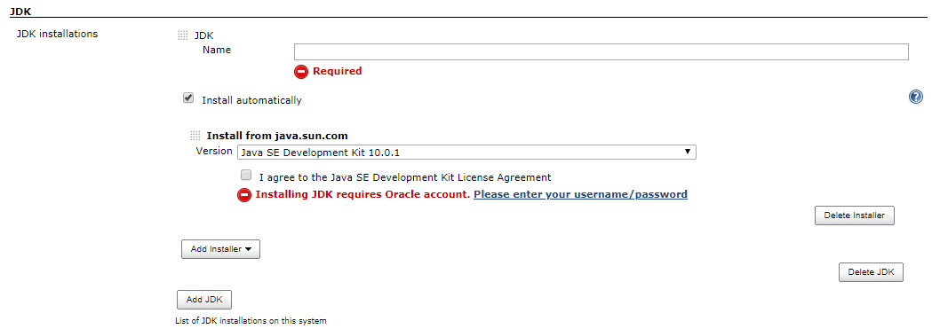

Note: Uncheck the “Install automatically”.

Provide JDK Name:

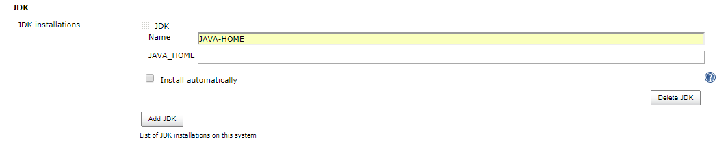

Again Click on Add Ant

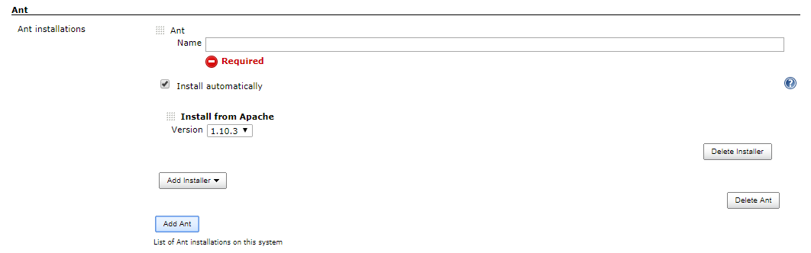

Note: Remove “Install automatically”.

Provide Ant Name

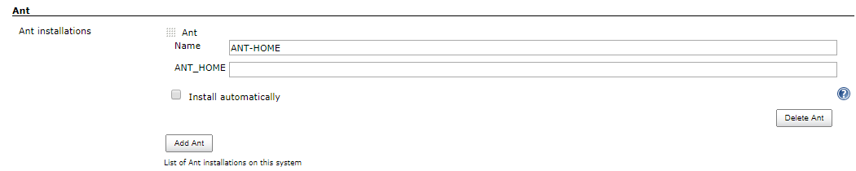

Scroll down and Click on “Save”.

Click on Node Name i.e., prac1.

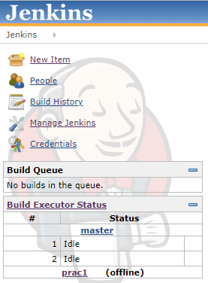

Click “Configure”.

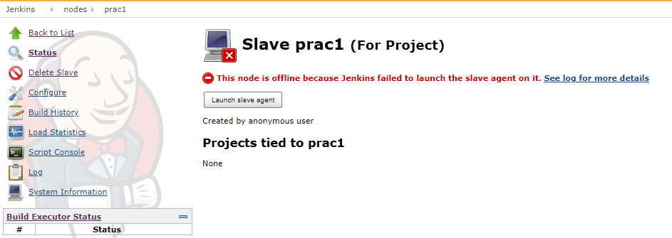

We can see below display.

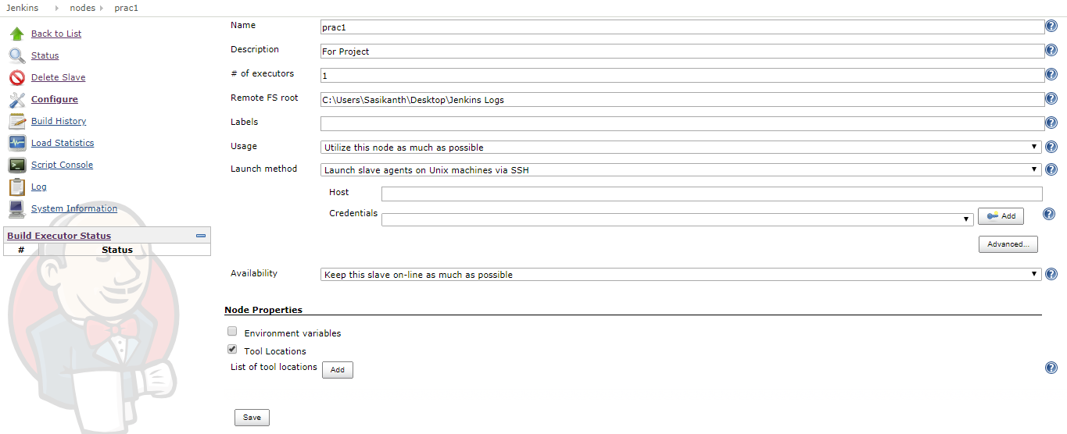

At Tool Location click “Add”.

At Name click drop down box and select displayed Name and provide the path of JAVA and ANT.

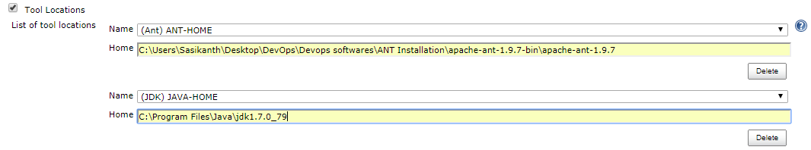

Change the Launch Method: Launch slave agents via Java Web start.

Click Save.

Once saved we can see below display.

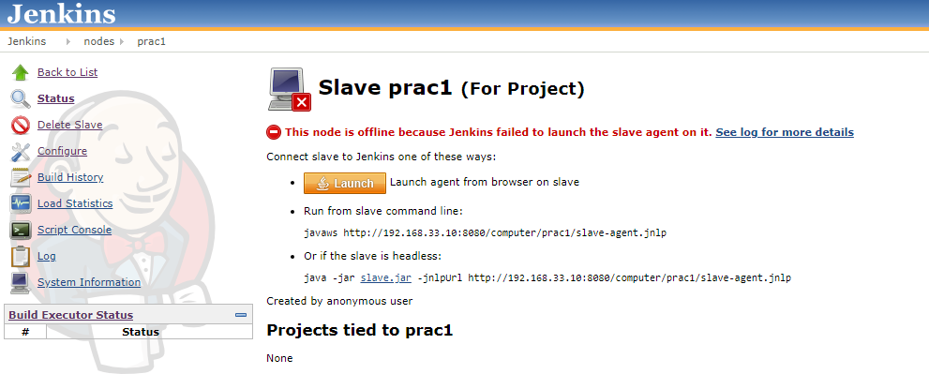

Click on Launch.

It will download the “slave-agent.jnlp” file in our local machines.



Double click to open fil slave-agent (4).jnlp

It will show JAVA and the prompt Security Warning.

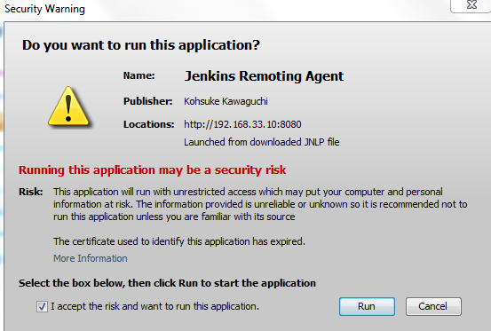

Click check box “I accept the risk and want to run this application”.

Click Run.

We can see Jenkins slave agent is connected.

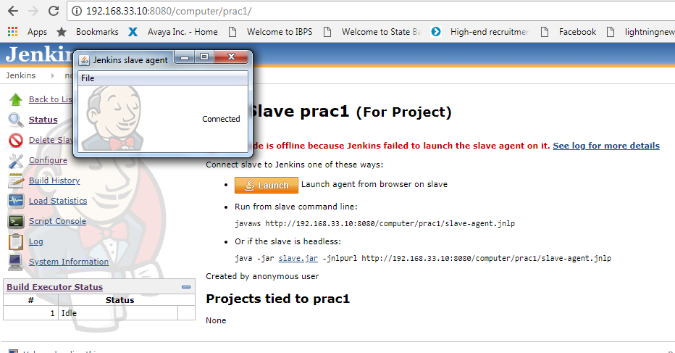

Click on Back to List

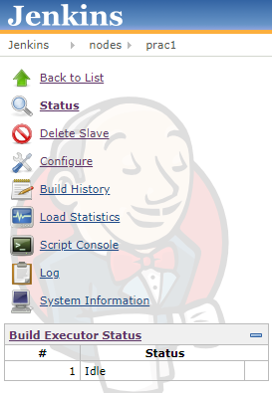

Click on Back to Dashboard

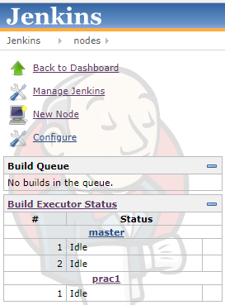

Click on New Item

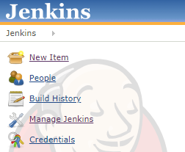

Once we click on New Item, it will show below page.

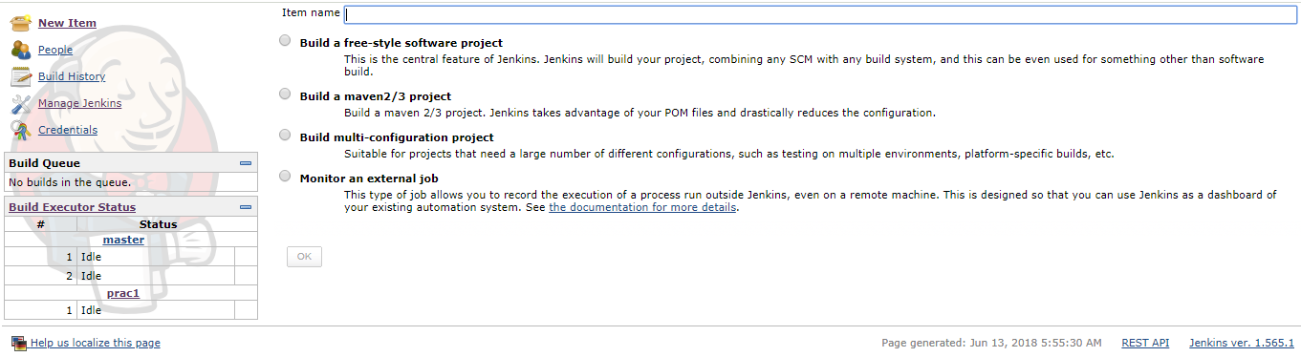

Provide Item Name and select Build a free-style software project.

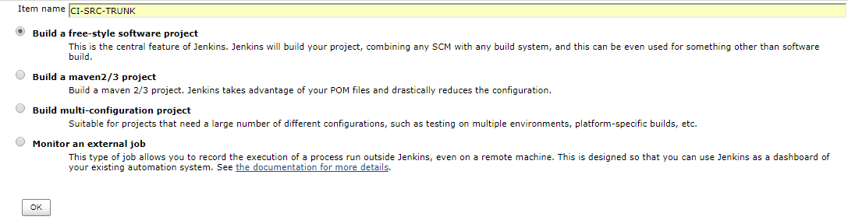

Click OK.

We can see below page.

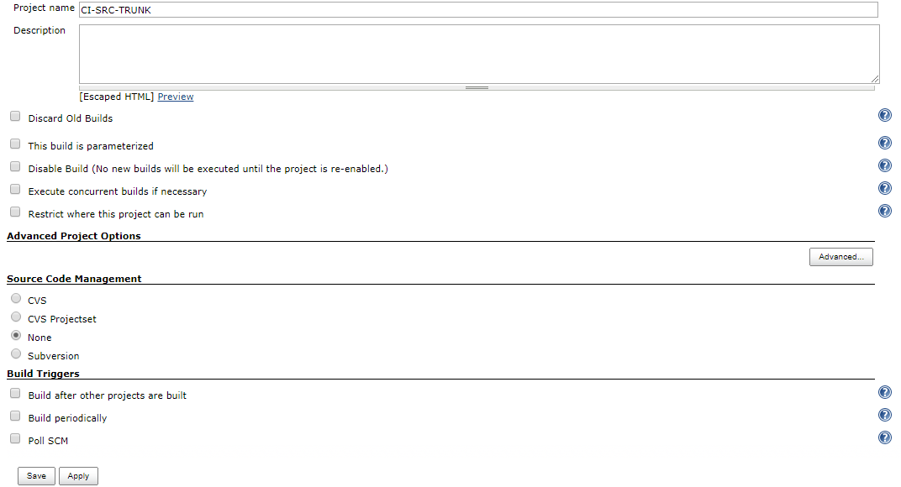

Do check on “Restrict where this project can be run”.

Provide node name i.e., prac1.

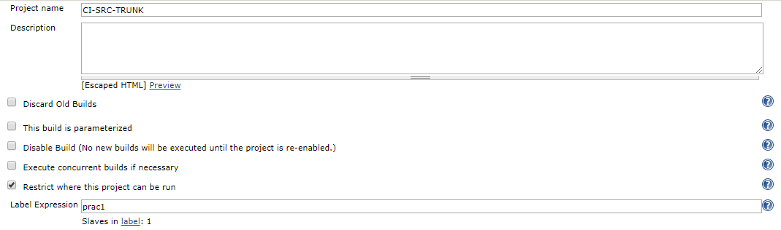

Scroll down and at Source Code Management select Subversion.

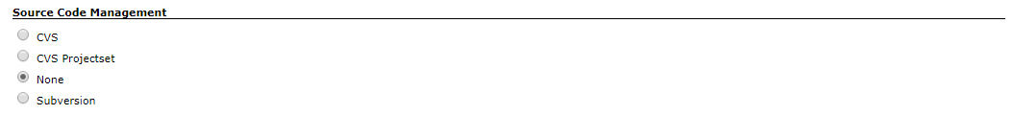

After clicking Subversion we can see below display.

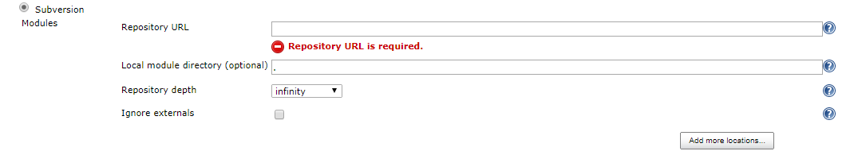

Provide Repository URL i.e., copy the path from here.

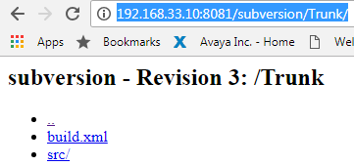

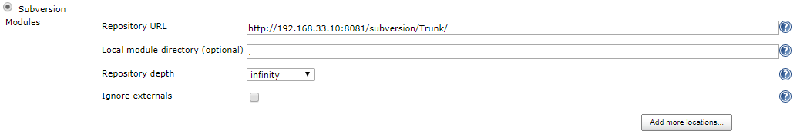Scroll down

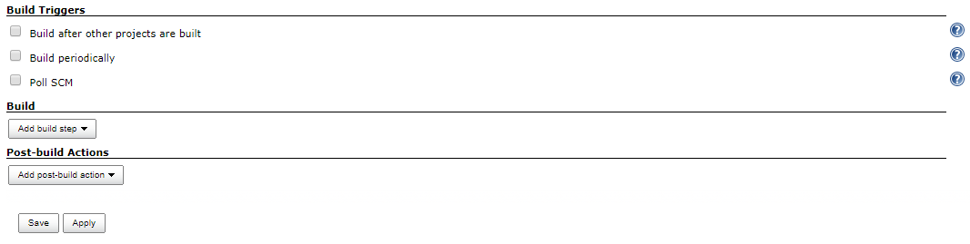

At **Build** 🡪 **Add build step** (click drop down)

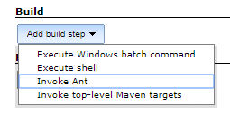

Select Invoke Ant.

By default Ant version will be in “Default”.

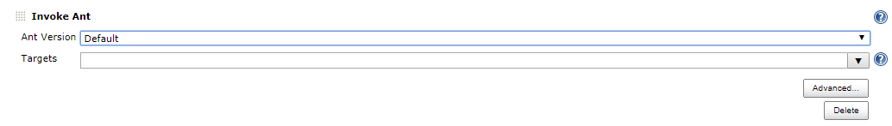

Click on Drop down and select ANT-HOME.

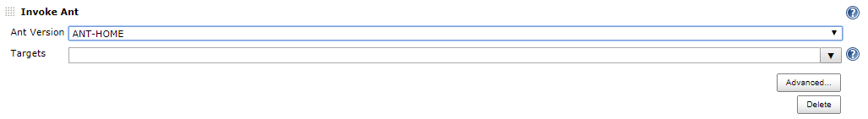

At Post-build Actions:

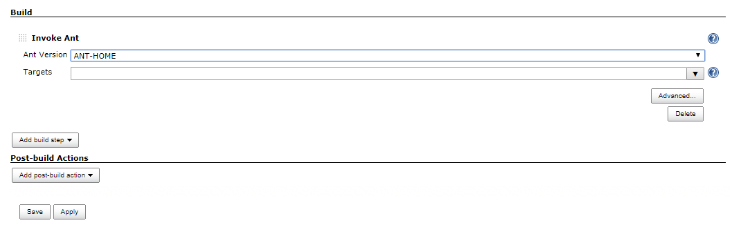

Click on Add post-build action dropdown and select “Archive the artifacts”.

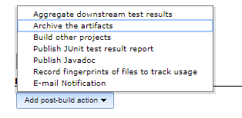

At Files to archive, set path **/*.jar

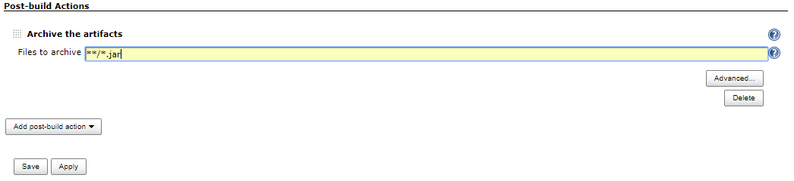

Click on “Apply” and “Save”.

Once we saved we can see below page.

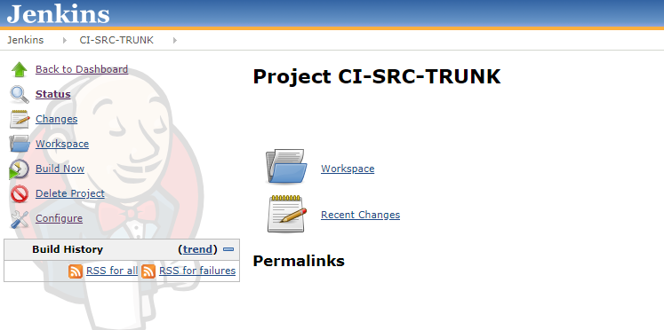

Click on Build Now.

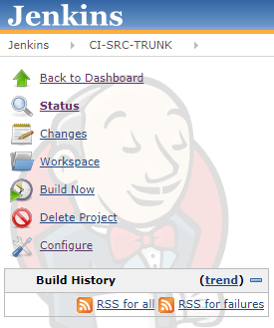

We can see Build History

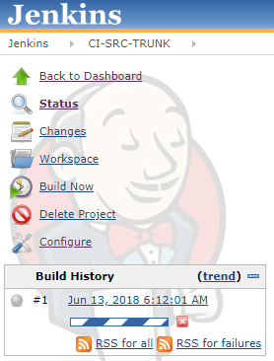

Click on the ball icon

We can in Console Output build status i.e., compile, package, run and then BUILD SUCCESSFUL message.

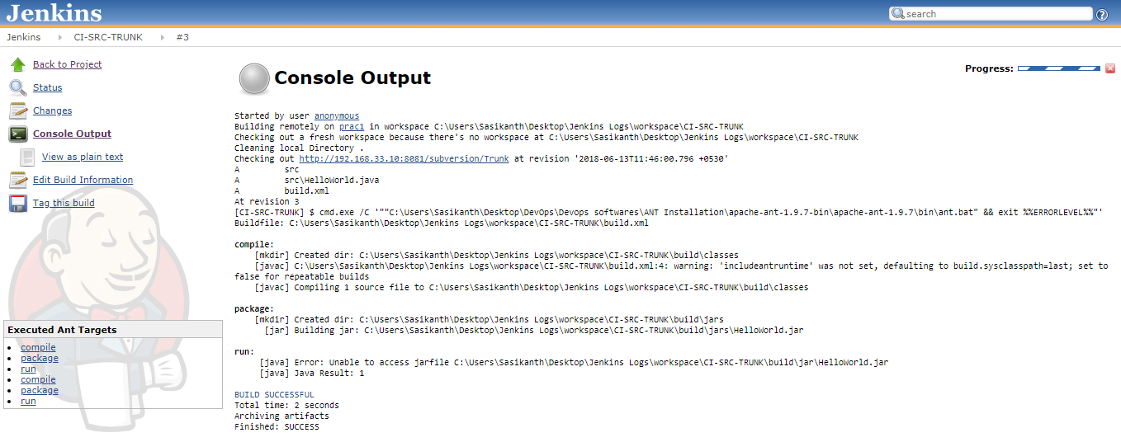

Click on **Back to Project**

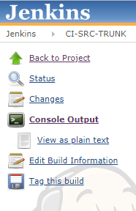

Click on **Back to Dashboard**.

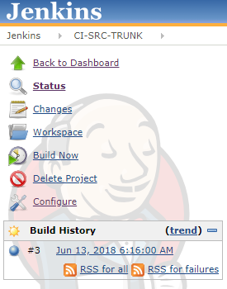

We can see below display:

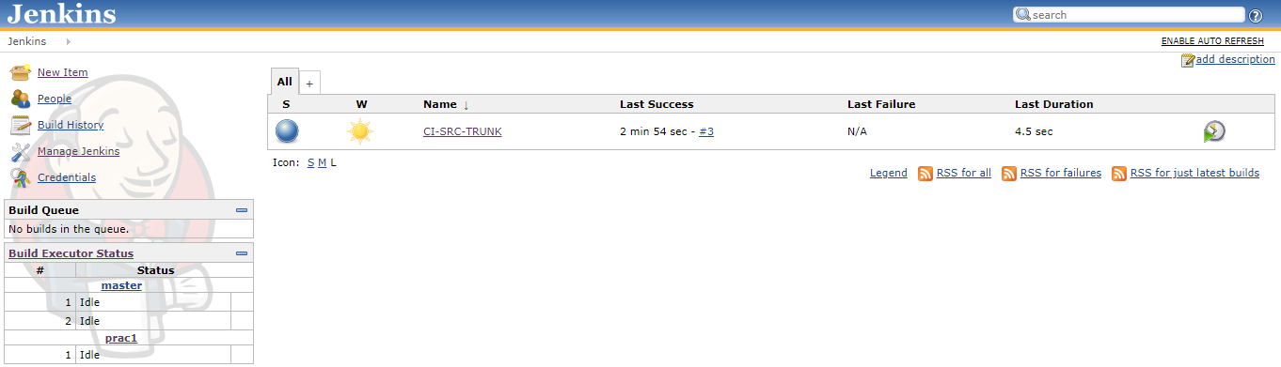

**How to check our package has created and where it got stored?**

Go to Desktop and open “Jenkins Logs” folder.

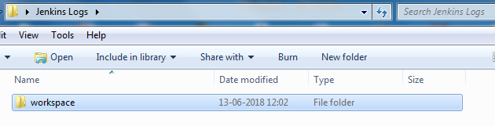

Click on “workspace” folder.

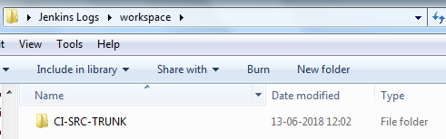

We can see the name CI-SRC-TRUNK which we given in Item-Name in Jenkins.



Click “CI-SRC-TRUNK” folder.

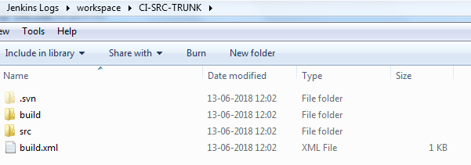

Click on folder build 🡪 jars

We can see “HelloWorld.jar” file created.

